Periodicity Nature of Some Systems of Difference Equations

¹Q. Din, ²M.N. Qureshi and ²A.Q. Khan

¹Department of Mathematics,
Faculty of Basic and Applied Sciences, University of Poonch, Rawalakot, Rawalakot 12350, Pakistan
²Department of Mathematics, University of Azad Jammu & Kashmir, Muzaffarabad 13100, Pakistan

Abstract: In this paper, we study the solutions and periodicity behavior of some systems of fourth-orderrational difference equations with positive initial conditions. Some numerical examples are givento verify our theoretical results.

Key words: System of rational difference equations • periodicity nature of solutions

INTRODUCTION

Recently, studying the qualitative behavior of difference equations and systems is a topic of a great interest. Applications of discrete dynamical systems and difference equations have appeared recently in many areas such as ecology, population dynamics, queuing problems, statistical problems, stochastic time series, combinatorial analysis, number theory, geometry, electrical networks, neural networks, quanta in radiation, genetics in biology, economics, psychology, sociology, physics, engineering, economics, probability theory and resource management. Unfortunately, these are only considered as the discrete analogs of differential equations. It is a well-known fact that difference equations appeared much earlier than differential equations and were instrumental in paving the way for the development of the latter. It is only recently that difference equations have started receiving the attention they deserve. Perhaps this is largely due to the advent of computers where differential equations are solved by using their approximate difference equation formulations. The theory of discrete dynamical systems and difference equations developed greatly during the last twenty five years of the twentieth century. The theory of difference equations occupies a central position in applicable analysis. There is no doubt that the theory of difference equations will continue to play an important role in mathematics as a whole. Nonlinear difference equations of order greater than one are of paramount importance in applications. It is very interesting to investigate the solutions of a system of higher-order rational difference equations and to discuss the periodicity nature of solutions.
Cinar [1] investigated the periodicity of the positive solutions of the system of rational difference equations:

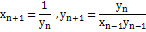

Stevic [2] studied the system of two nonlinear difference equations:

where u_{n}, v_{n}, w_{n}, s_{n} are some sequences x_{n} or y_{n}.
Stevic [3] studied the system of three nonlinear difference equations:

where the parameters a_{i}, b_{i}, c_{i}, i∈{1,2,3} are real numbers.
Bajo et al. [4] investigated the global behavior of difference equation:

for all values of real parameters a,b.

Kalabusic et al. [5] investigated the global dynamics of the following system of difference equations:

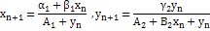

Kurbanli et al. [6] studied the behavior of positive solutions of the system of rational difference equation:

Touafek et al. [7] studied the periodic nature and got the form of the solutions of the following systems of rational difference equations:

Din et al. [8] investigated the dynamics of a system of fourth-order rational difference equations:

Recently, Touafek et al. [9] studied the periodicity nature of the following systems of rational difference equations:

Our aim in this paper is to investigate the solutions and periodicity nature of a system offourth-order rational difference equations:

with the initial conditions x₋₃, x₋₂, x₋₁, x₀

and

ON THE SYSTEM

In this section we study the solutions of following system:

with the initial conditions

such that

Theorem 1: Let be solution of system (2). Then for n≥-3 one has

=
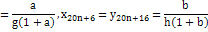
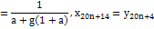
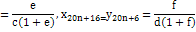
Where

Proof: Results are obvious for n = 0. Suppose that results are true for n = k≥1. Then for n = k+1 using system (2) one has:

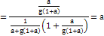
and

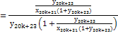
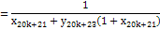
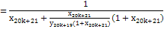
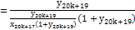

Similarly one has:

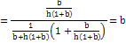

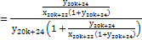
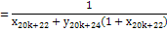
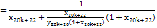
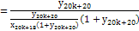

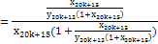
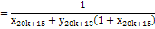
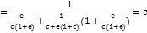

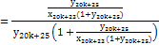

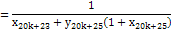
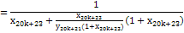
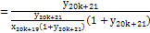

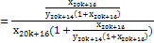
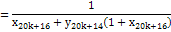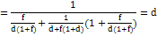

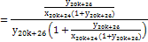
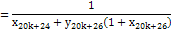
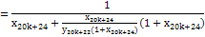
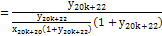

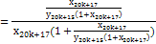
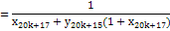
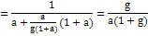

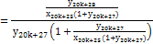
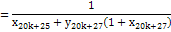

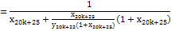
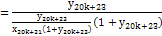

Similarly, one can prove the other results.
The following theorem shows periodicity nature of system (2).

Theorem 2: Let be solution of system (2). Then for n≥-3 the following results hold:

(i)
(ii)

Proof
(i) Using system (2) one has:

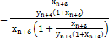
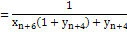
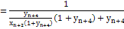
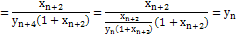
and

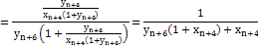
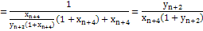
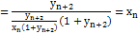

(ii) Using system (2) and (i) one has:

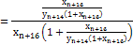
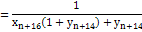
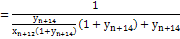
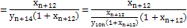
and
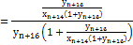
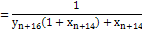
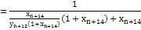
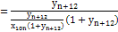

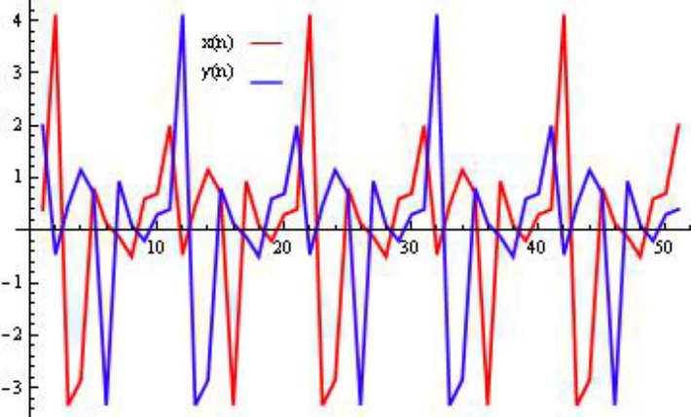

Fig. 1: Plot of

Hence, the proof is completed.

Example 1: Consider the System (2) with initial conditions x₋₃ = 0.1, x₋₂ = -0.2, x₋₁ = 0.3, x₀ = 0.4, y₋₃ = -0.5, y₋₂ = 0.6, y₋₁ = 0.7, y₀ = 2
Figure 1 shows periodicity nature of solutions of System (2) with initial conditions x₋₃ = 0.1, x₋₂ = -0.2, x₋₁ = 0.3, x₀ = 0.4, y₋₃ = -0.5, y₋₂ = 0.6, y₋₁ = 0.7, y₀ = 2

ON THE SYSTEM

In this section following system is discussed:

with the initial conditions x₋₃, x₋₂, x₋₁, x₀, y₋₃, y₋₂, y₋₁, y₀ are non-zero real numbers such that

and .

Theorem 3: Let be solution of system (3). Then for n≥-3 one has

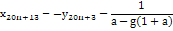
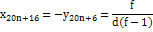
where

.

Proof: Results are obvious for n = 0. Suppose that results are true for n = k≥1. Then for n = k+1 using system (3) one has:

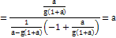
and
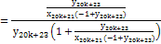
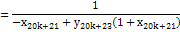
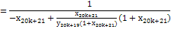
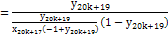

Similarly one has:

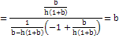

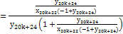

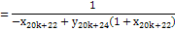
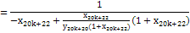
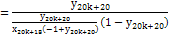

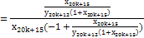
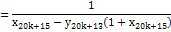
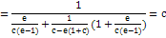

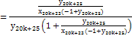
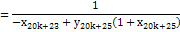
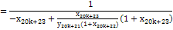
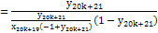
.

Similarly, one can prove the other results.

Theorem 4: Let be solution of system (3). Then for n≥-3 the following results hold:

Proof
(i) Using system (3) one has:

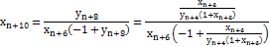
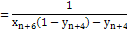

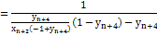
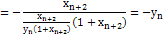
and
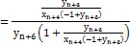
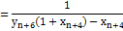
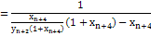
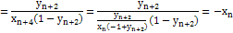

(ii) Using system (3) and (i) one has:

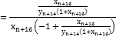
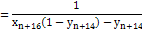
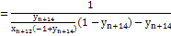
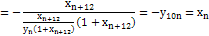
and
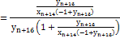
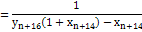
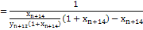
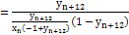

Example 2: Consider the System (3) with initial conditions x₋₃ = 1, x₋₂ = 2, x₋₁ = 3, x₀ = 4, y₋₃ = 5, y₋₂ = 6, y₋₁ = 7, y₀ = 8

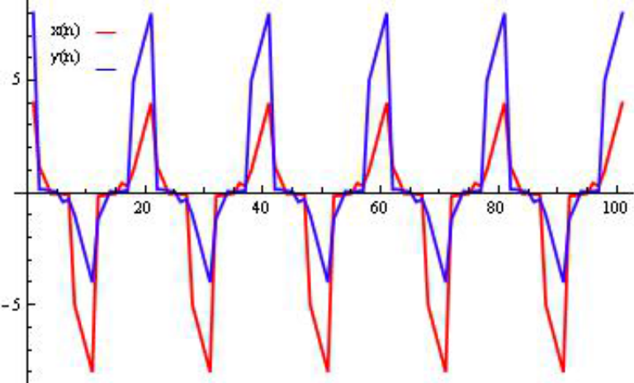

Fig. 2: Plot of

Figure 2 shows periodicity nature of solutions of System (3) with initial conditions x₋₃ = 1, x₋₂ = 2, x₋₁ = 3, x₀ = 4, y₋₃ = 5, y₋₂ = 6, y₋₁ = 7, y₀ = 8

ON THE EQUATION

In this section, we study the following system:

with the initial conditions

such that

Theorem 5: Let be solution of system (4). Then for n≥-3 one has

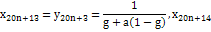

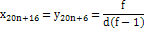

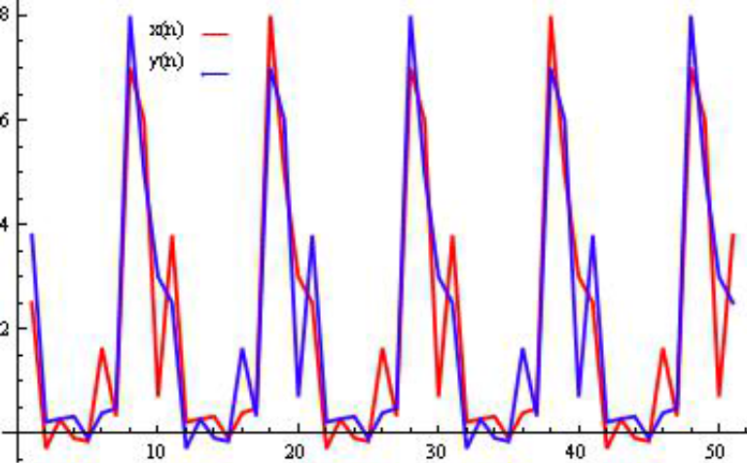

Fig. 3: Plot of

where, x₋₃ = a, x₋₂ = b, x₋₁ = c, x₀ = d, y₋₃ = e, y₋₂ = f, y₋₁ = g, y₀ = h

Proof: The proof is similar to Theorem 1 and Theorem 3. Hence, it is omitted.

Theorem 6: Let be solution of system (4). Then for n≥-3 the following results hold:

Proof: The proof is similar to Theorem 2 and Theorem 4. Hence, it is omitted.

Example 3: Consider the System (4) with initial conditions x₋₃ = 8, x₋₂ = 5, x₋₁ = 3, x₀ = 2.5, y₋₃ = 7, y₋₂ = 6, y₋₁ = 0.7, y₀ = 3.8
Figure 3 shows periodicity nature of solutions of System (4) with initial conditions x₋₃ = 8, x₋₂ = 5, x₋₁ = 3, x₀ = 2.5, y₋₃ = 7, y₋₂ = 6, y₋₁ = 0.7, y₀ = 3.8 such that α = β = -1.

ON THE SYSTEM

In this section, we study the following system:

with the initial conditions x₋₃, x₋₂, x₋₁, x₀, y₋₃, y₋₂, y₋₁, y₀ are non-zero real numbers such that

, and

Theorem 7: Let be solution of system (5). Then for n≥-3 one has

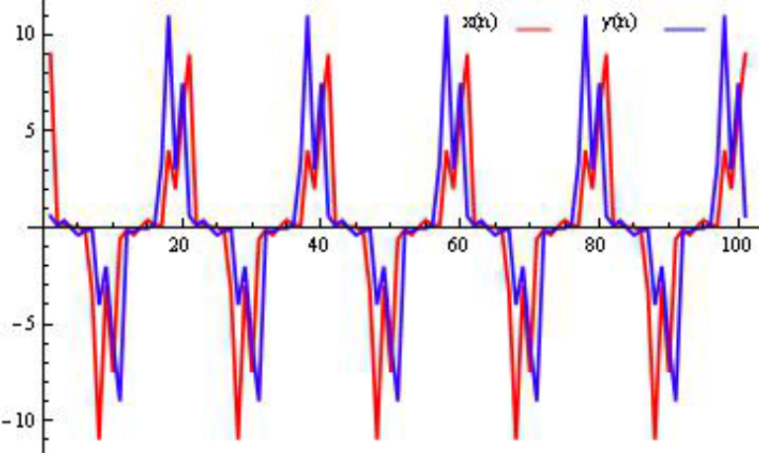

Fig. 4: Plot of

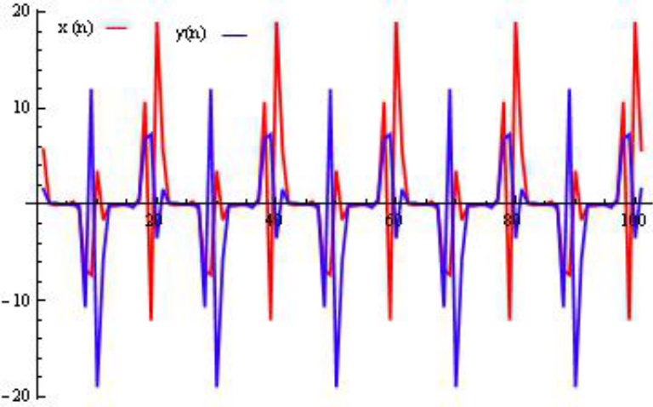

Fig. 5: Plot of

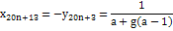

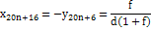

where, x₋₃ = a, x₋₂ = b, x₋₁ = c, x₀ = d, y₋₃ = e, y₋₂ = f, y₋₁ = g, y₀ = h

Theorem 8: Let be solution of system (5). Then for n≥-3 the following results hold:

Example 4: Consider the System (5) with initial conditions x₋₃ = 4, x₋₂ = 2, x₋₁ = 6, x₀ = 9, y₋₃ = 11, y₋₂ = 3, y₋₁ = 7.5, y₀ = 0.6

Figure 4 shows periodicity nature of solutions of System (5) with initial conditions x₋₃ = 4, x₋₂ = 2, x₋₁ = 6, x₀ = 9, y₋₃ = 11, y₋₂ = 3, y₋₁ = 7.5, y₀ = 0.6

Example 5: Consider the System (5) with initial conditions x₋₃ = 10.7, x₋₂ = -12, x₋₁ = 19, x₀ = 5.7, y₋₃ = 6.8, y₋₂ = 7.3, y₋₁ = -3.5, y₀ = 1.6.
Figure 5 shows periodicity nature of solutions of System (5) with initial conditions x₋₃ = 10.7, x₋₂ = -12,x₋₁ = 19,x₀ = 5.7, y₋₃ = 6.8, y₋₂ = 7.3, y₋₁ = -3.5, y₀ = 1.6.

ACKNOWLEDGEMENTS

This work was supported by the Higher Education Commission of Pakistan.

REFERENCES

1. Cinar, C., 2004. On the positive solutions of the difference equation system Applied Mathematics and Computation, 158: 303-305.
2. Stevic, S., 2012. On some solvable systems of difference equations, App. Math. And Comput., 218: 5010-5018.
3. Stevic, S., 2012. On a third-order system of difference equations. App. Math. and Comput., 218: 7649-7654.
4. Bajo, I. and E. Liz, 2011. Global behaviour of a second-order nonlinear difference equation. J. Differ. Eq. Appl., 17 (10): 1471-1486.

5. Kalabusic, S., M.R.S. Kulenovic and E. Pilav, 2011. Dynamics of a two-dimensional system of rational difference equations of Leslie-Gower type. Advances in Difference Equations, doi:10.1186/ 1687-1847-2011-29.
6. Kurbanli, A.S., C. Cinar and I. Yalcinkaya, 2011. On the behavior of positive solutions of the systemof rational difference equations Mathematical and Computer Modelling, 53: 1261-1267.
7. Touafek, N. and E.M. Elsayed, 2012. On the solutions of systems of rational difference equations. Mathematical and Computer Modelling, 55: 1987-1997.
8. Din, Q., M.N. Qureshi and A.Q. Khan, 2012. Dynamics of a fourth-order system of rational difference equations. Ad. Diff. Eq., 1: 1-15.
9. Touafek, N. and E.M. Elsayed, 2012. On the periodicity of some systems of nonlinear difference equations. Bull. Math. Soc. Sci. Math. Roumanie, 2: 217-224.
10. Elabbasy, E.M., H. El-Metwally and E.M. Elsayed, 2012. Some properties and expressions of solutions for a class of nonlinear difference equation. UtilitasMathematica, 87: 93-110.
11. Khan, A.Q., M.N. Qureshi, Q. Din and T.F. Ibrahim, 2014. Global behavior of an anti-competitive system of fourth-order rational difference equations. Computational Ecology and Software, 4 (1): 35-46.

